Simulation Lab- 3 Assignment (Odd Student ID)

- See the figure below:
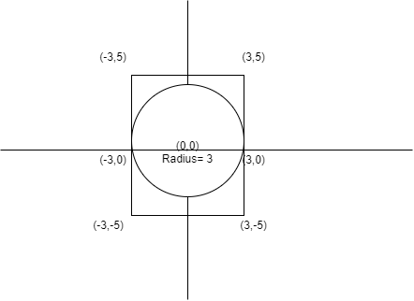

Using Monte Carlo simulation, find the value of PI and area of the circle using the given circle and square. You have to simulate the value for n=100,1000,5000 and 10000 trials. Show the scatter plot, value of PI, value of the area for each value of n. ( Just as shown in the class) .
At the end of the simulation, draw two-bar diagrams.
First Bar Plot: x-axis: number of trials, y-axis: PI -value (Shown in the class)
Second Bar Plot: x-axis: number of trials, y-axis: Area of the circle
Output Files:
https://drive.google.com/drive/folders/16y4BnVnyvGzWqfYs9wqilJRhDSD0mb9x?usp=sharing (Second Bar plot has not been shown. Do it yourself)

- Find the area under the given line below using the monte Carlo simulation.
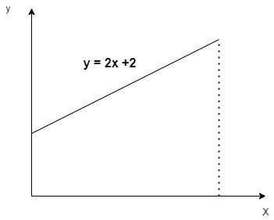
Simulate this area for n=100,1000,5000,10000 trials. For each value of n, print the area of the triangle and draw scatter plots for each case. Range of x is 0 to 3.

- Find the area under the curve below using the monte Carlo simulation. Use the drawn rectangle.

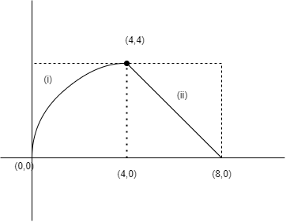

Equation of curve - (i) is : y² = 4x
Equation of (ii) is: y = 8 - x
Simulate this area for n=100,1000,5000,10000 trials. For each value of n, print the area and draw scatter plots for each case.

